
A Project Report

Student Performance Analysis

Submitted by
Student Name : R.Siva Kumar
Registration No :23BCE9372

VIT -AP UNIVERSITY
AMARAVATI
ANDHRA PRADESH,INDIA

- ABSTRACT 4
  - Key Words . . . . . . . . . . . . . . . . . . . . . . . . . . . . . . . . . . . 4
- INTRODUCTION 5
  - Problem Definition . . . . . . . . . . . . . . . . . . . . . . . . . . . . . . 5
  - Existing System . . . . . . . . . . . . . . . . . . . . . . . . . . . . . . . . 6
  - Proposed System . . . . . . . . . . . . . . . . . . . . . . . . . . . . . . . 6
  - Objectives of the Project . . . . . . . . . . . . . . . . . . . . . . . . . . . 6
  - Scope of the Project . . . . . . . . . . . . . . . . . . . . . . . . . . . . . 6
  - Advantages . . . . . . . . . . . . . . . . . . . . . . . . . . . . . . . . . . 7
  - Limitations . . . . . . . . . . . . . . . . . . . . . . . . . . . . . . . . . . 7
- SYSTEM REQUIREMENTS 8
  - Hardware Requirements . . . . . . . . . . . . . . . . . . . . . . . . . . . 8
  - Software Requirements . . . . . . . . . . . . . . . . . . . . . . . . . . . . 8
  - Software Requirements Specification (SRS) . . . . . . . . . . . . . . . . . 9
  - System Constraints . . . . . . . . . . . . . . . . . . . . . . . . . . . . . . 9
  - Assumptions and Dependencies . . . . . . . . . . . . . . . . . . . . . . . 9
- SYSTEM DESIGN 10
  - System Architecture . . . . . . . . . . . . . . . . . . . . . . . . . . . . . 10
  - Module Design 11
  - UML Diagrams 12
  - Data Flow Diagram (DFD) 17
  - Database Design 18
  - Flowchart 18
  - Design Principles 20
  - Design Constraints 20
  - Summary 20

- IMPLEMENTATION 21
  - Development Environment 21
    - Tools and Technologies Used 21
  - Project Structure 22
  - Backend Implementation 22
  - API Development 22
  - Database Implementation 22
  - Frontend Implementation 22
  - Data Processing and Analysis 22
  - Visualization Implementation 23
  - Authentication System 23
  - Error Handling 23
  - Security Implementation 23
  - Testing 24
  - Deployment 24
  - Summary 24
- RESULTS AND TESTING 25
  - Results 25
  - Test Cases 26
  - Performance Testing 26
  - Error Handling 26
  - Security Testing 26
  - Outputs 27
  - Limitations 28
  - Future Enhancements 29
  - Summary 29
- CONCLUSION 30
  - Future Scope 30
  - Final Summary 31

Chapter 1 ABSTRACT
The Student Performance Analysis system is a web-based application designed to analyze and improve student academic performance using data-driven techniques. The system collects student data such as marks, attendance, and academic records, and processes it to generate meaningful insights. It integrates Machine Learning algorithms such as Decision Tree and Logistic Regression to predict future student performance based on historical data.
The system also provides graphical visualizations including bar charts, pie charts, and line graphs to help users easily interpret performance trends. It enables educators and administrators to identify weak and strong students, monitor progress, and take informed decisions. By combining automation, data analysis, visualization, and predictive modeling, the system enhances academic performance evaluation and supports effective decision-making in educational institutions.

Key Words
Student Performance Analysis, Machine Learning, Prediction, Data Analysis, Visualiza-tion, Decision Tree, Logistic Regression, Educational Data Mining.

Chapter 2 INTRODUCTION
In recent years, the education sector has witnessed a rapid increase in the generation of student-related data due to the adoption of digital platforms. Educational institutions collect large volumes of data such as student marks, attendance records, assignment scores, and behavioral patterns. However, extracting meaningful insights from this data and predicting future performance remains a significant challenge.
To address this issue, the project “Student Performance Analysis” has been developed. This system provides an intelligent and user-friendly platform that analyzes student aca-demic data and generates insights to improve performance. The system integrates data processing techniques with Machine Learning algorithms to identify patterns, predict outcomes, and support effective decision-making.
The application allows administrators or faculty members to input student data, in-cluding marks, attendance, and other academic indicators. The system preprocesses and analyzes this data, and applies Machine Learning models such as Logistic Regression or Decision Tree to predict student performance. It then generates reports, visualizations, and predictive insights that help educators take timely actions.
Overall, the system bridges the gap between raw educational data and actionable insights by combining automation, analysis, visualization, and Machine Learning-based prediction.

Problem Definition
Many educational institutions face challenges in analyzing student performance due to the absence of proper analytical tools, reliance on manual evaluation processes, difficulty in identifying weak students, and inability to accurately predict future academic outcomes. Traditional methods often focus only on historical data and lack intelligent systems to analyze patterns and trends.
Furthermore, the absence of Machine Learning-based approaches limits the ability to

perform predictive analysis, making it difficult to identify at-risk students in advance. These limitations often result in delayed interventions, inefficient decision-making, and reduced academic improvement.

Existing System
Currently, institutions rely mainly on manual methods such as spreadsheets and tradi-tional grading systems. These approaches are time-consuming and prone to human errors. Additionally, they do not support predictive analysis or effective visualization, making it difficult for educators to understand performance trends clearly.

Proposed System
The proposed system is a web-based application designed to automate student perfor-mance analysis. It provides secure user authentication, efficient student data manage-ment, automated performance evaluation, graphical visualization through charts, and prediction of future performance using Machine Learning techniques.
The system utilizes historical student data such as marks and attendance to train a predictive model, which helps in identifying performance patterns and forecasting student outcomes. This approach enhances the accuracy of analysis and supports data-driven decision-making. Overall, the system simplifies academic analysis and provides intelligent insights for improving student performance.

Objectives of the Project
The main objective of the project is to develop an automated system for analyzing student performance. It aims to identify weak and strong students, provide meaningful insights, and assist educators in improving academic outcomes through data-driven decisions.
Another important objective is to incorporate Machine Learning techniques to predict student performance based on historical academic data such as marks and attendance. This helps in early identification of students who may need additional support and enables proactive academic intervention.

Scope of the Project
The scope of this project includes analyzing academic data, generating visual reports, and predicting student performance. The system is designed for educational institutions to improve performance monitoring and decision-making processes.

Advantages
    - Reduces manual effort
    - Provides accurate analysis
    - Saves time
    - Helps identify weak students early

Limitations
    - Depends on data quality
    - Requires internet connection

Chapter 3
SYSTEM REQUIREMENTS

System requirements define the essential hardware and software components required for the development, deployment, and smooth functioning of the Student Performance Analy-sis system. These requirements ensure that the system operates efficiently while handling student data, processing analysis, and generating reports. The system is designed to be user-friendly, scalable, and efficient.

Hardware Requirements
The hardware requirements include both minimum and recommended configurations. The minimum configuration consists of an Intel Core i3 processor, 4 GB RAM, 250 GB storage, and a display with 1280×720 resolution, along with a minimum internet speed of 2 Mbps. For better performance, the recommended configuration includes an Intel Core i5 processor, 8 GB RAM, 256 GB SSD storage, Full HD display, and internet connectivity of at least 5 Mbps. Additional hardware such as smartphones can be used for testing
purposes.

Software Requirements
The system supports multiple operating systems including Windows, Linux, and macOS. The development environment includes tools such as Visual Studio Code or PyCharm and version control using Git and GitHub. The frontend is developed using HTML, CSS, and JavaScript, while the backend uses Python or Node.js to handle logic and processing. The database system used is MongoDB or MySQL to store student records, marks, and results.
The system also integrates chart libraries such as Chart.js or Matplotlib for visualiza-tion and uses SMTP services for notifications. Testing tools like Postman and browser developer tools are used for debugging and validation.

Software Requirements Specification (SRS)
The system includes several functional modules such as user authentication, student data management, performance analysis, visualization, prediction, and report generation. These modules work together to ensure smooth operation of the system.
The non-functional requirements include performance, scalability, security, usability, reliability, maintainability, and portability. The system ensures fast data processing, secure user access, easy usability, and compatibility across multiple devices.

System Constraints
The system requires a stable internet connection and depends on the accuracy of input data. It has limited offline functionality and relies on server and database availability.

Assumptions and Dependencies
It is assumed that users have basic computer knowledge and that the data entered into the system is accurate. The system depends on database connectivity, server performance, and internet availability for proper functioning.

Chapter 4 SYSTEM DESIGN
System design is a crucial phase in software development where the architecture, compo-nents, modules, interfaces, and data flow of the system are defined. It acts as a bridge between system requirements and implementation. The Student Performance Analysis system is designed to provide an efficient, scalable, and user-friendly platform for analyz-ing student academic data. The design follows a modular and layered approach to ensure flexibility, maintainability, and performance.

System Architecture
The system follows a three-tier architecture consisting of the presentation layer, appli-cation layer, and data layer. The presentation layer represents the frontend where users interact with the system. It is responsible for displaying dashboards, collecting user input such as student marks and attendance, and presenting analysis results through graphs and reports. Technologies such as HTML, CSS, and JavaScript are used to build a responsive and user-friendly interface.
The application layer acts as the backend of the system and handles all business logic and data processing. It processes user inputs, performs performance analysis, generates predictions, and communicates with the database. This layer is implemented using tech-nologies such as Python with Flask or Django, or Node.js, ensuring efficient handling of requests and smooth execution of system functionalities.
The data layer is responsible for storing and managing all system data. It uses database systems such as MySQL or MongoDB to store student records, marks, at-tendance, and analysis results. This layer ensures data consistency, security, and efficient retrieval.
The overall workflow of the system begins when the user enters student data through the frontend interface. The request is sent to the backend, where the data is processed and analyzed. The processed results are then stored in the database and displayed back

to the user in the form of reports and visualizations.
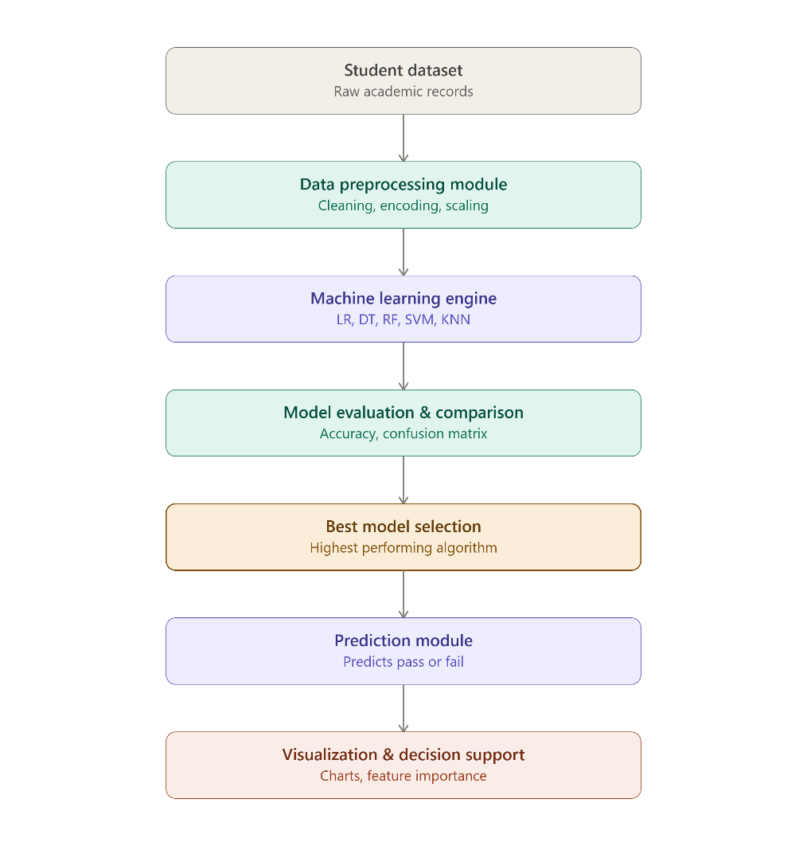

Figure 4.1: System Architecture

Module Design
The system is divided into multiple modules to ensure better organization and main-tainability. The user module handles user registration, login, and profile management, ensuring secure authentication and session handling. The student data module is respon-sible for managing student records, including adding, updating, and deleting data, while ensuring proper validation.
The performance analysis module forms the core of the system and is responsible for calculating average marks, identifying weak students, and analyzing performance trends. The visualization module generates graphical representations such as bar charts, pie charts, and line graphs to make the analysis more understandable.
The prediction module uses Machine Learning algorithms such as Logistic Regression or Decision Tree to analyze historical student data and predict future performance. The model takes inputs such as marks and attendance and classifies student performance into categories like Excellent, Average, or Needs Improvement. This helps educators in

making informed decisions and providing timely support to students.
The admin module provides control over the system, allowing administrators to man-age users, monitor activities, and generate reports.
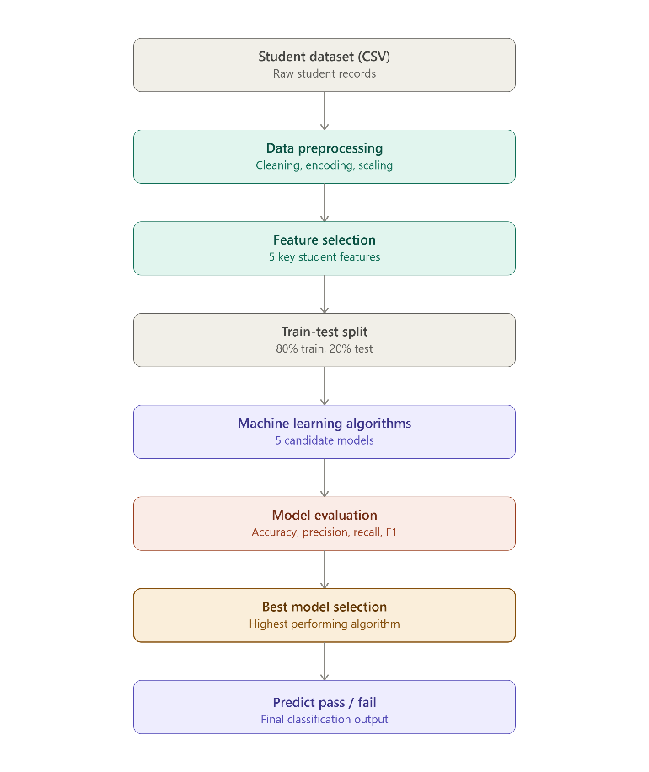

Figure 4.2: Modules

UML Diagrams
UML diagrams are used to visually represent the structure and behavior of the system.

Use Case Diagram: The use case diagram illustrates the interaction between users and the system. It shows activities such as login, data entry, performance analysis, and report generation. It helps in understanding system functionality from a user perspective.
In addition, the system includes Machine Learning-based prediction as part of the analysis process, where user-provided data is processed to generate performance insights. This diagram also highlights how both users and administrators interact with the system to view predictions, visualizations, and reports for effective decision-making.

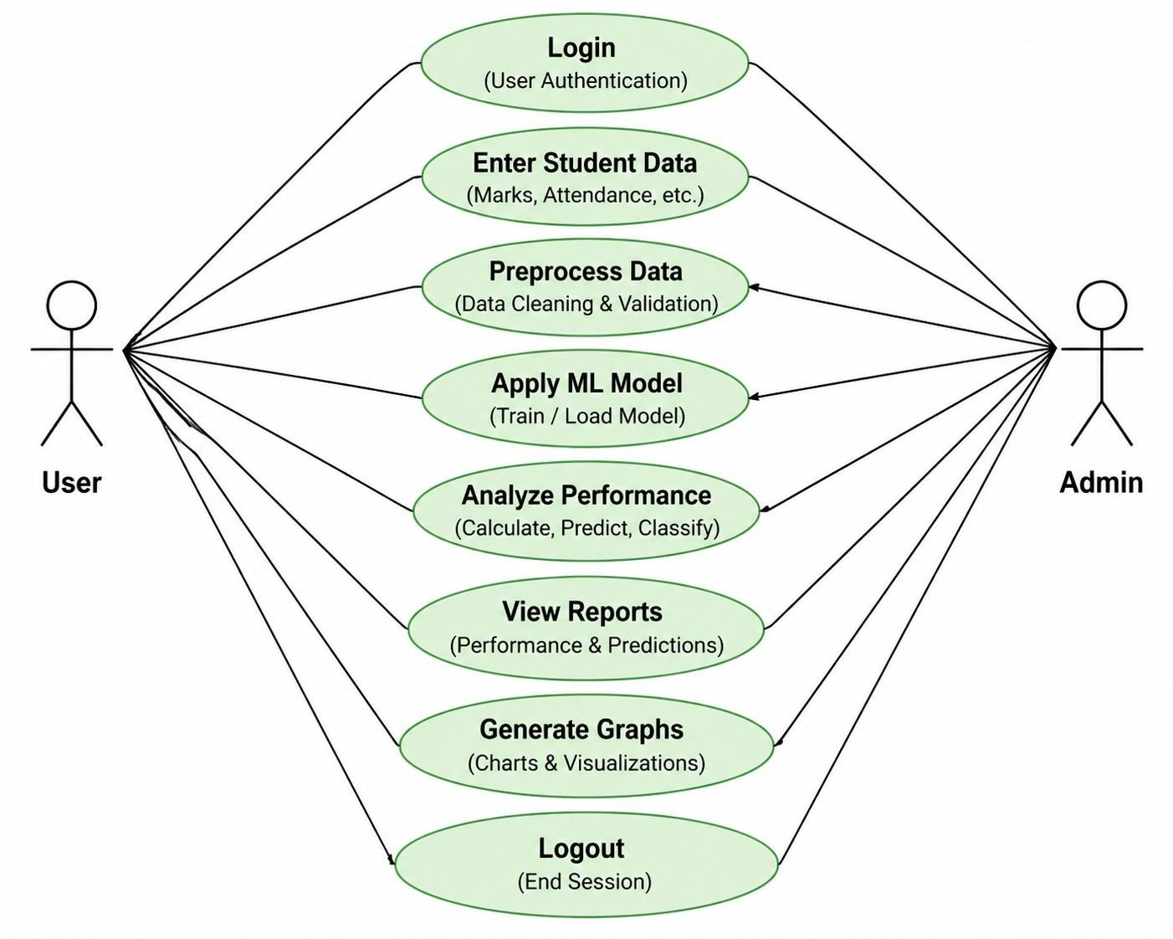

Figure 4.3: Use Case Diagram

Class Diagram: The class diagram defines the structural design of the system by representing key classes such as user, student, marks, attendance, and analysis. It illus-trates the attributes and functions associated with each class, providing a detailed view of system components. The diagram also shows the relationships between these classes, such as associations and dependencies, ensuring proper data flow within the system.
Additionally, the analysis class incorporates Machine Learning-based prediction func-tionality to estimate student performance using historical data. This enhances the system by integrating both analytical and predictive capabilities. Overall, the class diagram pro-vides a clear and organized representation of the system architecture.

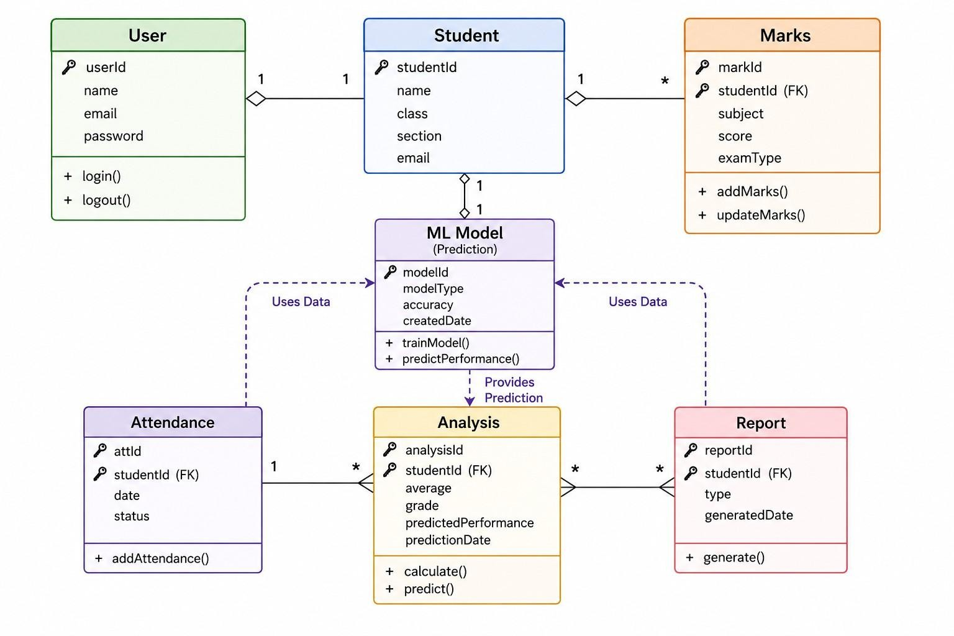

Figure 4.4: Class Diagram

Sequence Diagram: The sequence diagram represents the flow of operations in a step-by-step manner. It shows how the user interacts with the system during processes such as login, data input, and result generation. The diagram illustrates the interaction between different components like the frontend, backend, and database, highlighting the sequence of messages exchanged between them.
It also includes the Machine Learning process, where the backend preprocesses data, applies the prediction model, and generates performance insights. This helps in under-standing the order of execution as well as the integration of analytical and predictive operations within the system. Overall, it provides a clear view of how the system func-tions dynamically.

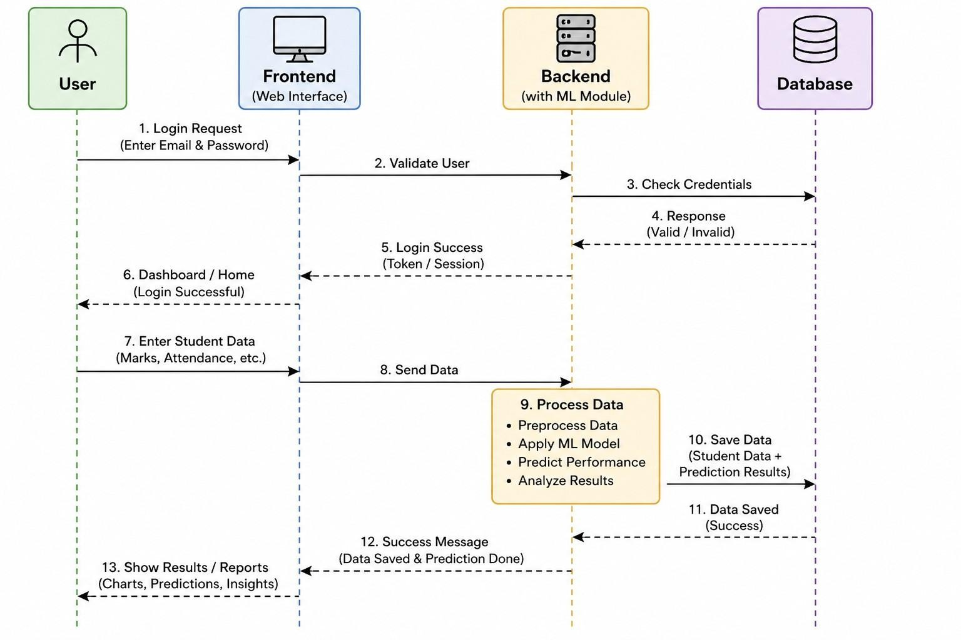

Figure 4.5: Sequence Diagram

Activity Diagram: The activity diagram describes the workflow of the system by illustrating the sequence of actions involved in processing student data. It shows the flow starting from user login and data entry, followed by data preprocessing and analysis. The diagram also includes the application of Machine Learning models to predict student performance based on historical data.
Further, it represents decision points such as data validation and error handling to ensure accurate processing. The workflow continues with performance analysis, visual-ization, and report generation. Overall, it helps in visualizing the complete process flow, including both analytical and predictive operations within the system.

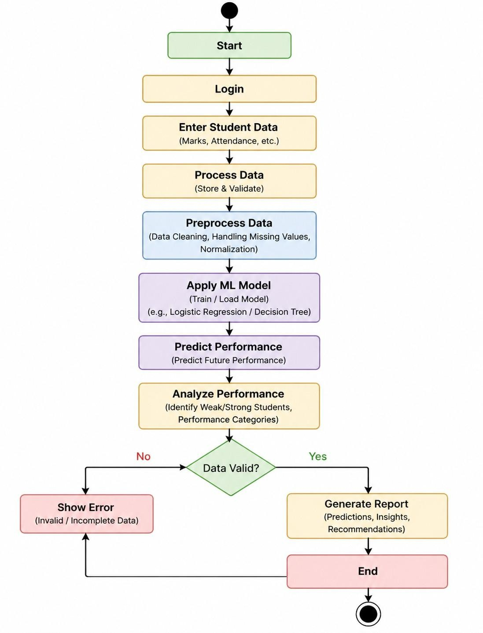

Figure 4.6: Activity Diagram

Data Flow Diagram (DFD)
The Data Flow Diagram represents how data moves within the system. At the highest level, the system takes student data as input and produces performance reports as output. At a more detailed level, the system includes processes such as data input, processing, analysis, and visualization, all of which interact with the database.
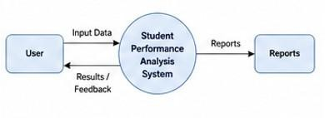

Figure 4.7: Data Flow Diagram - Level 0

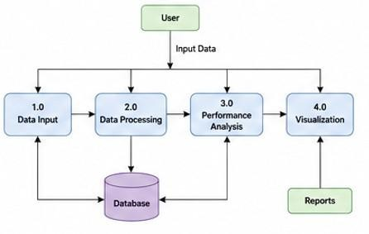

Figure 4.8: Data Flow Diagram - Level 1

Database Design
The database is designed to efficiently store and manage student-related information. It includes tables such as students, marks, attendance, and results. Each student record is associated with marks and attendance data, which are used to generate performance analysis results. The database ensures data integrity, consistency, and efficient retrieval.
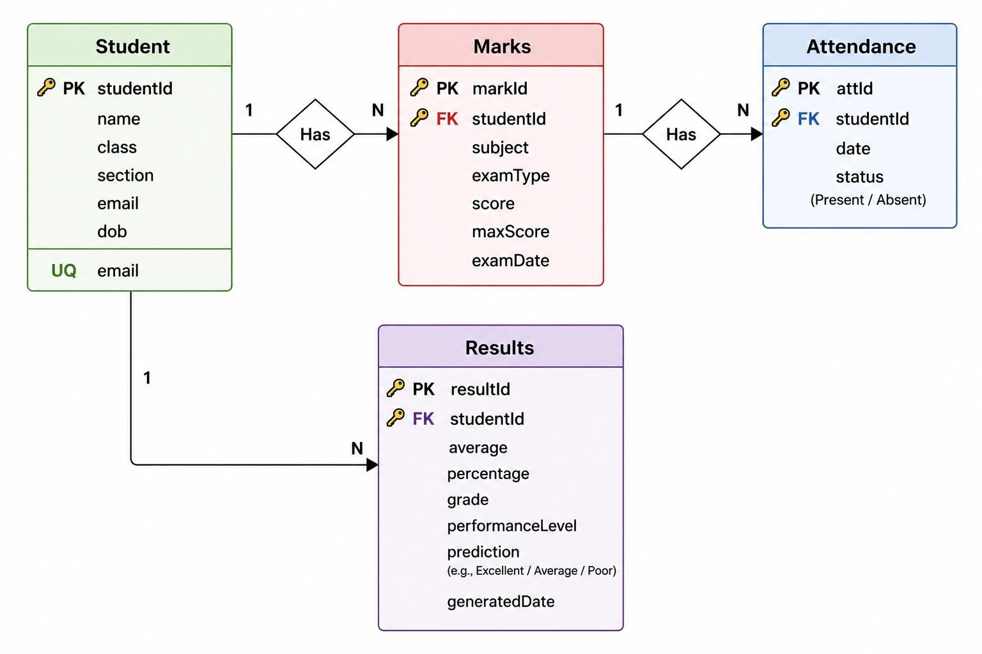

Figure 4.9: Database Diagram - ER

Flowchart
The system flow begins with user login or registration, followed by entering student data. The data is then processed and analyzed, after which the system generates reports and displays the results to the user. The process ends after successful output generation.

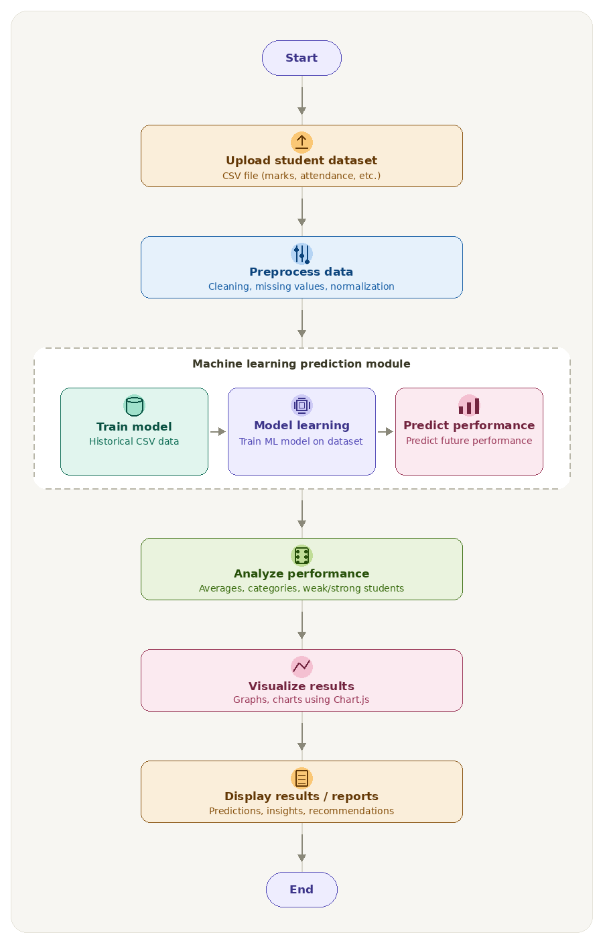
Figure 4.10: Flow ChartDesign Principles
The system is designed based on principles such as modularity, scalability, security, us-ability, and performance. Modularity ensures that the system is divided into independent components, making it easier to maintain. Scalability allows the system to handle an in-creasing number of users. Security ensures protection of user data, while usability focuses on providing an easy-to-use interface. Performance ensures fast processing and efficient operation.

Design Constraints
The system requires an active internet connection for proper functioning and depends on the accuracy of the input data. It has limited offline capabilities and relies on system resources such as memory and processing power for efficient execution.

Summary
The system design provides a structured and organized approach for developing the Stu-dent Performance Analysis system. It ensures efficient data handling, accurate analysis, and a user-friendly interface, making it suitable for educational institutions.

Chapter 5 IMPLEMENTATION
Implementation is the phase where the system design is converted into a functional appli-cation using programming languages, tools, and technologies. In this project, the imple-mentation focuses on developing a web-based system that analyzes student performance and provides meaningful insights through data processing and visualization.
The system is developed using modern web technologies, where the frontend is built using HTML, CSS, and JavaScript, and the backend is implemented using Python or Node.js. The database is managed using MongoDB or MySQL. These technologies ensure that the system is efficient, scalable, and capable of handling real-time data processing.

Development Environment
The development environment includes various tools required for building and testing the application. Integrated Development Environments such as Visual Studio Code or PyCharm are used for coding. The backend runtime environment includes Python or Node.js, and the database is managed using MongoDB or MySQL. API testing is per-formed using tools such as Postman.

Tools and Technologies Used

Layer | Technology
Frontend | HTML, CSS, JavaScript
Backend | Node.js
Database | MongoDB
Visualization | Chart.js
Machine Learning | Scikit-learn (Decision Tree)
Table 5.1: Technologies Used in the System

Project Structure
The project follows a modular structure consisting of frontend, backend, and database components. The frontend handles user interaction, the backend processes data and implements logic, and the database stores all required information.

Backend Implementation
The backend is responsible for handling system logic and data processing. It initializes the server, manages routes, and processes requests received from the frontend. The backend performs operations such as data validation, performance analysis, and report generation. It also communicates with the database to store and retrieve data efficiently.

API Development
The system uses RESTful APIs to enable communication between frontend and backend components. These APIs handle user authentication, student data entry, performance analysis, and report generation. Proper response handling and status codes are used to ensure reliable communication.

Database Implementation
The database is used to store student records, marks, attendance, and performance re-sults. The backend establishes a connection with the database using a connection string. The system supports CRUD operations, allowing users to create, read, update, and delete data. Data validation and error handling are implemented to maintain consistency.

Frontend Implementation
The frontend provides the user interface for interacting with the system. It is developed using HTML, CSS, and JavaScript to create a responsive and user-friendly interface. The frontend includes pages such as home, login, dashboard, data entry, and results display. It also ensures proper form validation and smooth navigation.

Data Processing and Analysis
The system processes student data to generate meaningful insights using both statistical methods and Machine Learning techniques. Initially, raw student data such as marks,

attendance, and academic records are collected and preprocessed. Data preprocessing includes handling missing values, data cleaning, and normalization to ensure accuracy and consistency.
After preprocessing, the system applies Machine Learning algorithms such as Logistic Regression or Decision Tree to analyze patterns in historical data. The model is trained using existing student records and is used to predict future performance categories such as Excellent, Average, or Needs Improvement.
In addition to prediction, the system calculates average marks, determines perfor-mance levels, and analyzes trends. The workflow begins with data input, followed by preprocessing, model training, prediction, and analysis, and ends with result generation and display.

Visualization Implementation
Visualization plays a key role in understanding student performance and Machine Learn-ing predictions. The system uses tools such as Chart.js or Matplotlib to generate graphical representations, including bar charts, pie charts, and line graphs.
These visualizations not only display academic performance trends but also represent predicted outcomes generated by the Machine Learning model. For example, performance categories and prediction results are visualized to help educators easily interpret insights and identify students who require attention.
This graphical representation enhances decision-making by presenting both actual and predicted data in an intuitive and user-friendly manner.

Authentication System
The system includes a secure authentication mechanism that allows users to register and log in. Password encryption and session management are implemented to ensure security.

Error Handling
The system is designed to handle errors effectively. It detects invalid inputs, missing data, and server issues, and displays appropriate error messages to the user.

Security Implementation
Security measures include secure login, data validation, and protection of user informa-tion. These measures ensure that the system is safe and reliable.

Testing
Testing was conducted to ensure that the system is free from errors and performs effi-ciently under different conditions. Unit testing was performed to verify individual mod-ules such as login functionality, data entry, and performance calculation. Each module worked correctly and produced expected outputs.
Integration testing was carried out to ensure that different modules work together properly. The interaction between frontend and backend, backend and database, and analysis and visualization modules was tested successfully.
System testing was conducted to evaluate the complete system. The entire workflow, from data entry to result generation, was executed without errors, and no system crashes were observed. User Acceptance Testing was also performed to evaluate the system from a user perspective. The feedback indicated that the system is easy to use, provides fast responses, and offers useful insights.

Deployment
The system can be deployed on platforms such as GitHub, Vercel, or local servers. De-ployment ensures that the application is accessible to users.

Summary
The implementation phase successfully converts the system design into a working ap-plication. The system integrates data processing, visualization, and analysis to provide accurate insights into student performance. It ensures efficient functionality, user-friendly interaction, and reliable performance.

Chapter 6
RESULTS AND TESTING

The Results and Testing phase is an essential part of the project as it evaluates the perfor-mance, accuracy, and reliability of the Student Performance Analysis system. This phase ensures that all modules function correctly and that the system meets both functional and non-functional requirements.
The system was developed using modern technologies such as Python or Node.js for backend processing, MongoDB or MySQL for data storage, and JavaScript-based libraries for visualization. The testing process was carried out to validate the correctness of each module and to ensure seamless integration of all system components.

Results
The implementation of the Student Performance Analysis system produced successful out-comes across all modules. The backend server executed efficiently and handled multiple requests without errors. Data processing operations, including performance calculations and Machine Learning-based predictions, were completed accurately.
The database performed effectively by storing and retrieving student records without any data loss. The system ensured data consistency and quick access to required infor-mation. The API layer functioned smoothly, enabling proper communication between the frontend and backend components with correct response handling.
The core analysis module successfully calculated average marks, identified weak and strong students, and generated meaningful performance insights. The Machine Learning model was able to predict student performance based on historical data with satisfactory accuracy, helping in early identification of students who need improvement.
The visualization module effectively displayed both actual and predicted data through graphs, making it easier for users to interpret results. The frontend interface was respon-sive and user-friendly, providing smooth navigation and quick loading of pages.
Overall, the system demonstrated high performance with successful integration of all

modules. It provided accurate analysis, reliable predictions, efficient processing, and a smooth user experience.

Test Cases

Test Case | Description | Expected Result | Status
TC01 | Login | Successful login | Pass
TC02 | Add Data | Data stored correctly | Pass
TC03 | Analysis | Accurate results | Pass
TC04 | Graph | Graph displayed | Pass

Performance Testing
The system was tested for performance under different conditions. The response time was observed to be less than two seconds, and the system efficiently handled multiple user requests. Data processing was fast and reliable, ensuring smooth system performance.

Error Handling
The system effectively handled different types of errors. Invalid inputs were detected and appropriate error messages were displayed. Missing data triggered validation mechanisms, and server-related issues were handled with proper alerts to ensure user awareness.

Security Testing
Security measures were tested to ensure safe system operation. The system includes secure login mechanisms, password protection, and proper data handling techniques to protect user information.

Outputs
This section includes screenshots of the application such as the login page, dashboard, data entry page, results page, and graphical visualizations, which demonstrate the func-tionality and performance of the system.

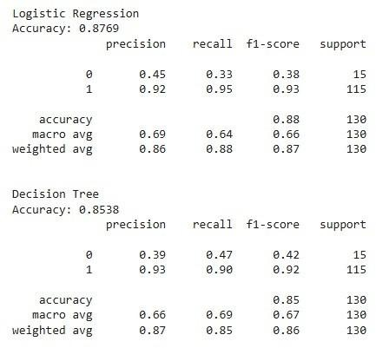

Figure 6.1: Logistic Regression and Decision Tree
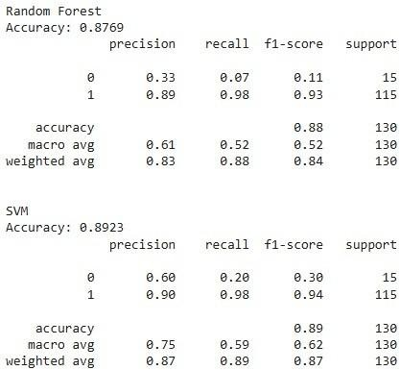

Figure 6.2: Random Forest and SVM

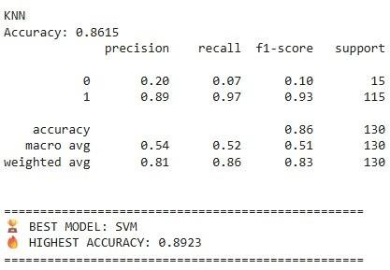

Figure 6.3: KNN
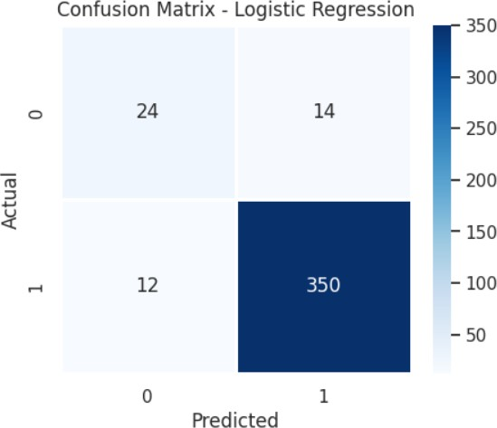

Figure 6.4: Confusion Matrix
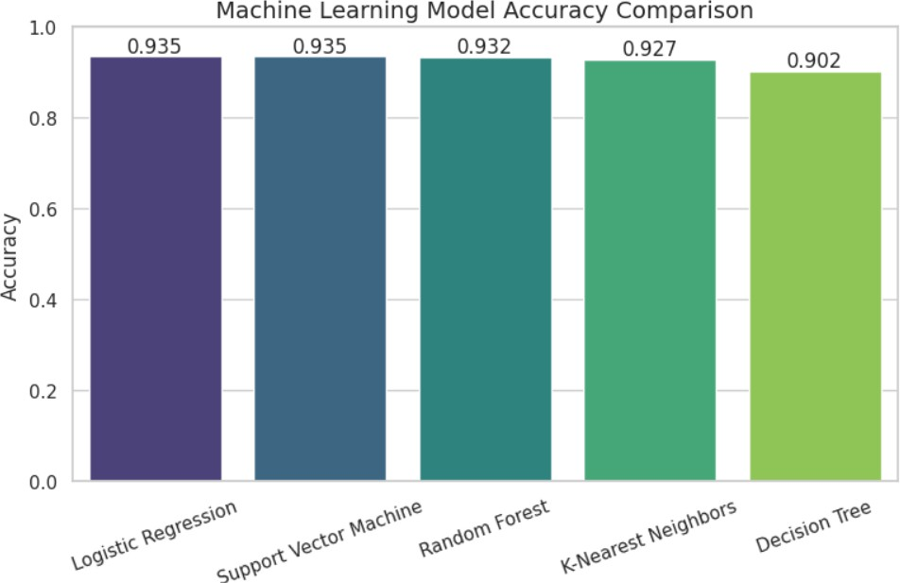

Figure 6.10: Best Model

Limitations
    - Depends on accuracy of input data
    - Limited prediction capability
    - Requires internet connection

Future Enhancements
    - Implementation of advanced Machine Learning models for improved prediction ac-curacy
    - Development of a mobile application for better accessibility
    - Advanced analytics dashboard with deeper insights
    - Real-time performance tracking and prediction updates

Summary
The system was successfully implemented and tested. All modules worked efficiently and produced accurate results. The system demonstrated high reliability, performance, and usability in analyzing student data and generating insights.

Chapter 7 CONCLUSION
The project “Student Performance Analysis” has been successfully designed, developed, and tested to provide an efficient solution for analyzing and improving student academic performance. The system offers a web-based platform where student data such as marks, attendance, and academic records can be processed and analyzed to generate meaningful insights.
The system helps in identifying performance patterns, evaluating trends, and support-ing educators in making informed decisions. By automating the process of analysis, it reduces manual effort and improves accuracy. The use of visualization techniques further enhances understanding by presenting data in a clear and interpretable format.
The application was implemented using modern technologies including HTML, CSS, and JavaScript for frontend development, Python or Node.js for backend processing, and MongoDB or MySQL for database management. These technologies ensure scalability, efficiency, and reliability of the system.
The system successfully implements key functionalities such as user authentication, student data management, performance analysis, data visualization, and report genera-tion. The testing phase confirmed that the system performs efficiently, produces accurate results, and provides a smooth user experience.
Overall, the system contributes to the education sector by improving academic perfor-mance monitoring, enabling data-driven decision-making, and providing valuable insights into student progress. It serves as a practical and effective solution for educational insti-tutions.

Future Scope
Although the current system is functional, several improvements can enhance its capa-bilities. Future developments may include integrating machine learning algorithms for more accurate performance prediction, developing a mobile application for better ac-

cessibility, and creating advanced dashboards for deeper insights. Additional features such as real-time monitoring, multilingual support, cloud integration, and personalized recommendations can further improve the system.

Final Summary
The Student Performance Analysis system demonstrates how technology can be effectively used to enhance educational outcomes. By combining data analysis and visualization, the system provides a reliable and efficient solution for monitoring student performance. With further enhancements, it has the potential to become a comprehensive platform for academic analysis and decision-making.

